**Assignment-4 [Conditional Statements and Keywords]**

[Submitted by **Malika Hafiza Pasha**]

**Please write Python Programs for all the problems.**

1. Take a variable age which is of positive value and check the following:
2. If age is less than 10, print “Children”.
3. If age is more than 60, print ‘senior citizens’
4. If it is in between 10 and 60, print ‘normal citizen’

**Answer:** [Python file is attached with the assignment file]

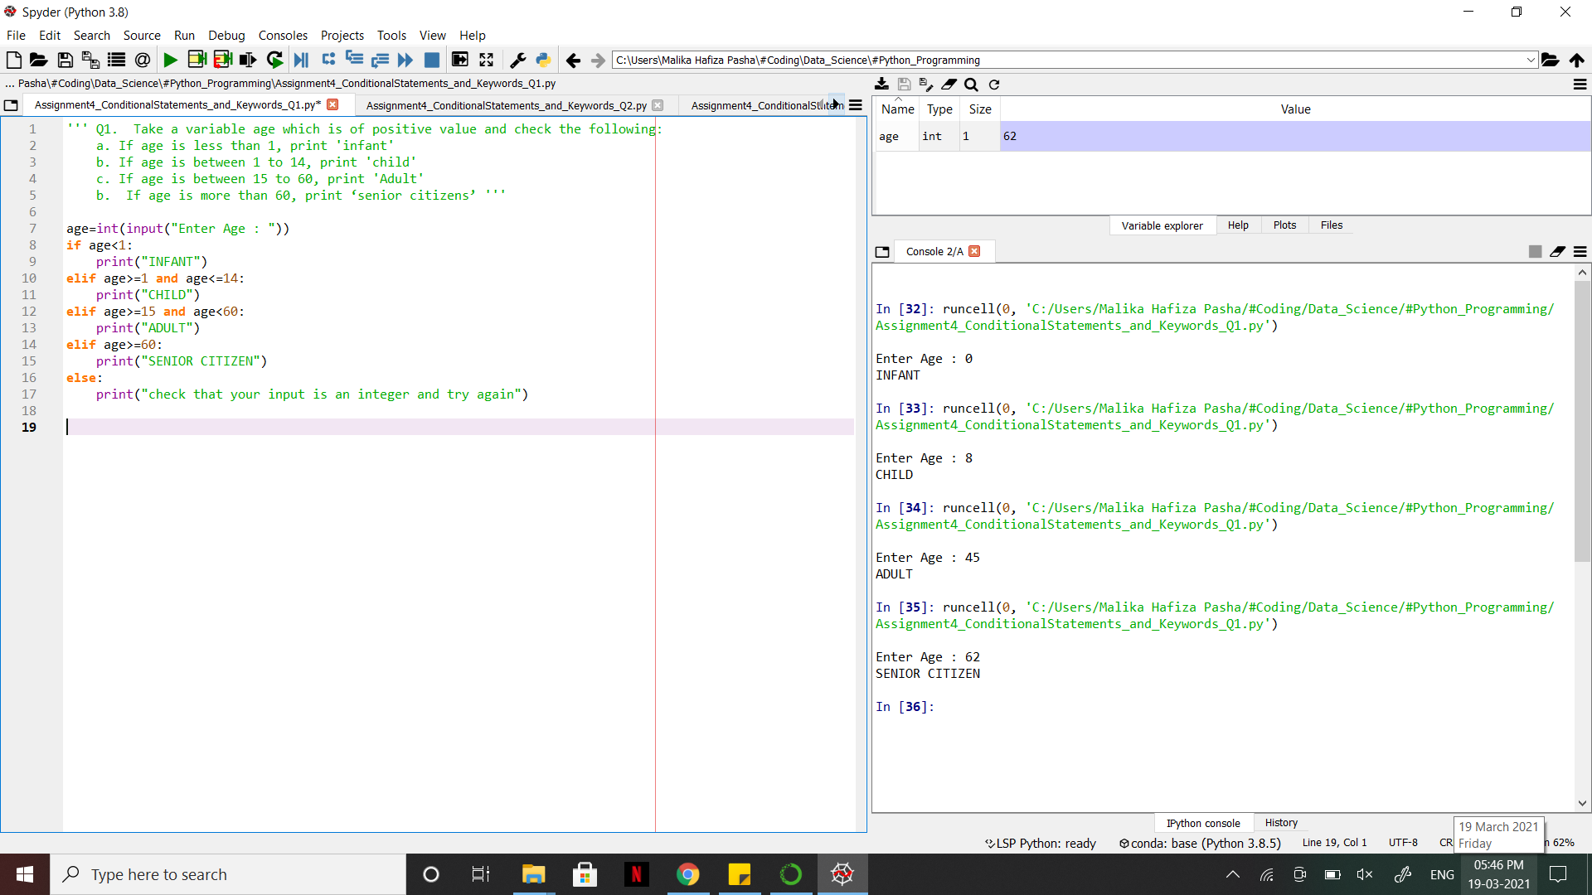

1. Find the final train ticket price with the following conditions.
2. If male and senior citizen, 70% of fare is applicable
3. If female and senior citizen, 50% of fare is applicable.
4. If female and normal citizen, 70% of fare is applicable
5. If male and normal citizen, 100% of fare is applicable

[Hint: First check for the gender, then calculate the fare based on age factor. For both Male and Female, consider them as senior citizens if their age >=60]

**Answer:** [Python file is attached with the assignment file]

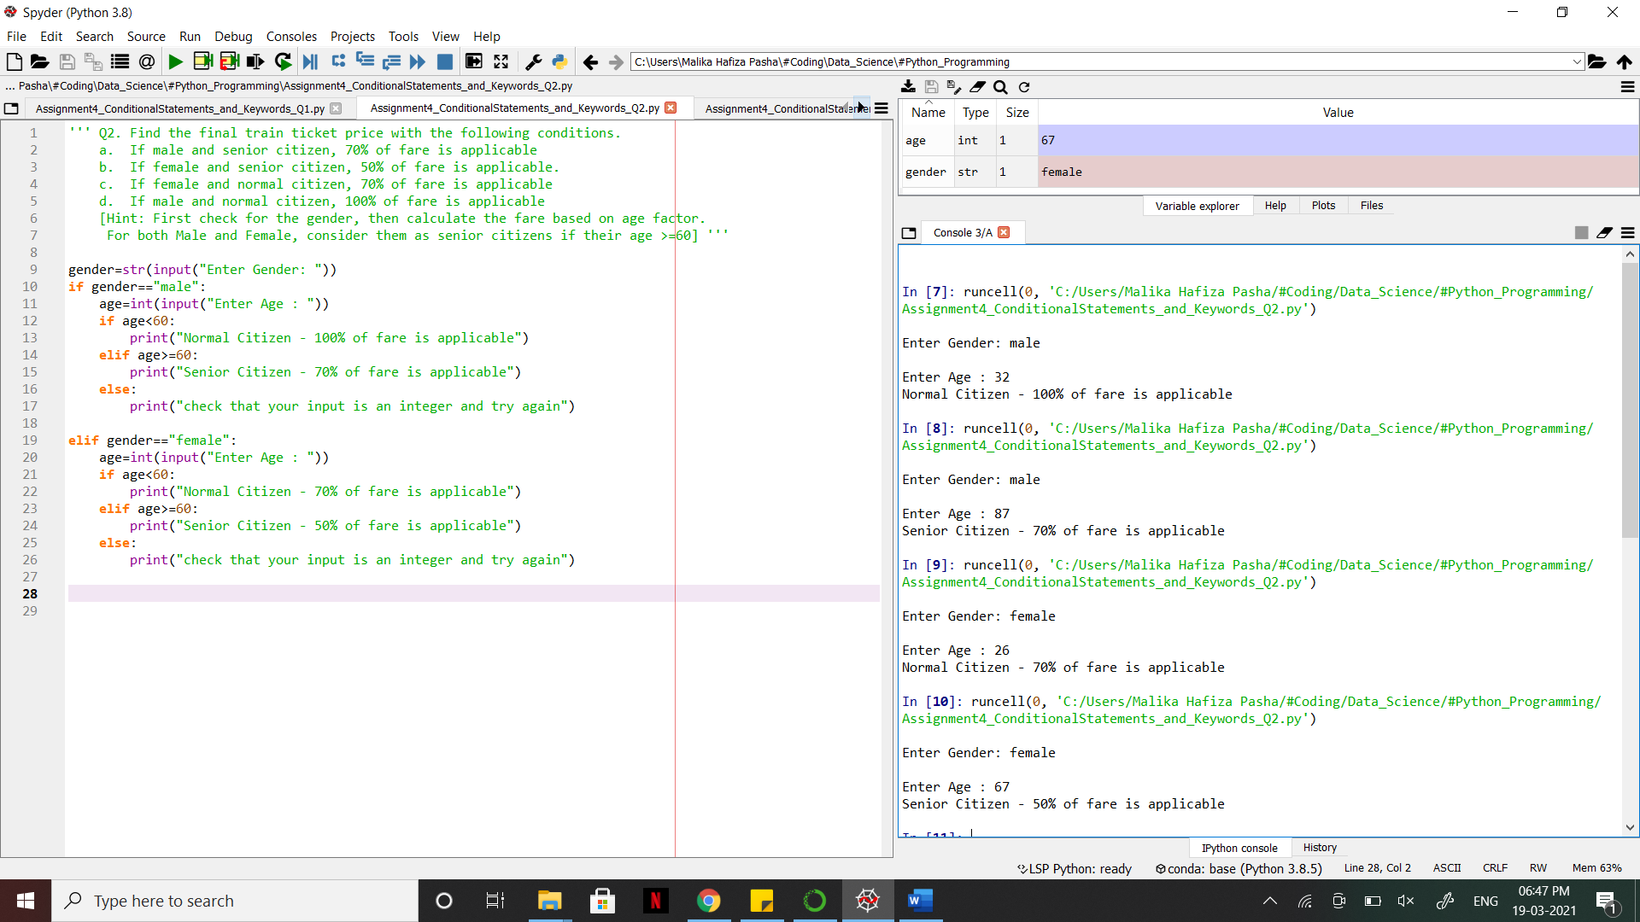

1. Check whether the given number is positive and divisible by 5 or not.

**Answer:** [Python file is attached with the assignment file]

